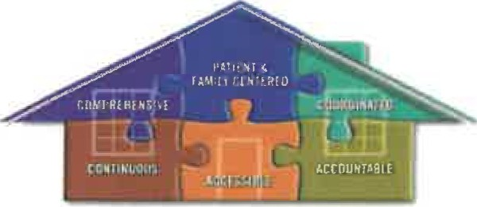
Patient Centered Medical Home
Nurture Pediatrics

Nurture Pediatrics began the process in 2018 of moving toward NCQA (National Committee for Quality Assurance) Patient Centered Medical Home certification. The NCQA Patient Centered Medical Home is a model of primary care that combines teamwork and information technology to improve care, improve patient's experience of care and reduce healthcare costs.

Comprehensive aspects of patient care including referrals, medication dispensing, diagnostic tests, immunization administrations and other services are provided by the practice. Our goal is to provide all of our patients with care that meets the highest level of excellence to maximize health and quality of life. As a practice we want to:

- Provide "whole child" care: We have care teams consisting of your selected primary pediatrician or nurse practitioner, our nursing staff, and our referral coordinators. The doctor or nurse practitioner will provide continuity of care for all areas of your child's health including mental and physical well-being. Our ancillary staff will help the provider coordinate and deliver that care to your child. This includes the services we provide in our office as well as coordinating services that may occur outside of our office, in the emergency room, hospital or with another doctor specializing in a specific area.

- Be readily available in the office to meet your child's healthcare needs: Our regular office hours are 7:00 AM – 4:45 PM, Monday through Friday and Saturday 8:00 AM – 11:30 AM. Labor Day to Memorial Day we offer late night clinic till 6:00 PM on Monday, Tuesday and Thursday.

- Be readily available by phone to meet your child's healthcare needs: During regular business hours, our receptionists and phone nurse are working hard to answer your call in a timely manner. After hours phone calls is available for urgent medical questions (615-223-5565 ext30)

- Communicate with all doctors and providers who take care of your child: Our referral coordinator works closely with outside providers to arrange specialist appointments for your child when necessary.

- Follow up on lab and imaging appointments and orders: Our staff works diligently to follow up on any lab tests, imaging tests or other procedures ordered by our doctors.

- Provide care that is based on the best medical evidence for prevention, diagnosis and treatment: Our providers follow all current American Academy of Pediatrics recommendations and Bright Futures guidelines.

- Support patient and family self-management of general health and chronic illnesses: While the care we deliver is certainly vital to your child's health, equally important is the self-management that will occur once you leave our office and care for your child at home. Whether we are helping you prevent illness and injury through counseling on healthy lifestyles and behaviors at well-child checks or providing instructions on an action plan to manage a chronic illness, we want to give you and all of our families the tools needed to maximize health at home.
The main goal in working for Medical Home recognition is to improve and maximize the care we provide for your child. A Patient Centered Medical Home is a partnership between the care team and the family. We will do everything we can to give your child excellent care, and we ask that you treat us as the central hub for your child's healthcare and keep us updated on any changes in your child's health. We hope you will view Nurture Pediatrics as your child's medical home.

